MINE FATALITY – On November 5, 2022, a miner died when he was engulfed in a coal stockpile.
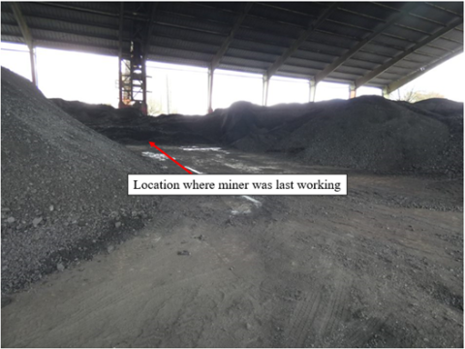

Best Practices
- Equip grates and feeders with mechanical clearing devices to prevent miners from being exposed to hazards of falling or sliding material.
- Make sure miners do not travel by foot on stockpiles or near the toe of stockpile slopes.
- Make sure miners can be seen, heard, or can communicate with others when working alone under hazardous conditions.
- Examine working places to identify the potential for falling or sliding materials prior to allowing access to areas in or around grates and feeders.

MINE FATALITY – On October 22, 2022, a mine examiner drowned in an underground sump. The mine examiner was assigned to start pumps in the area. The float switch box was found open with exposed electrical conductors inside the box.
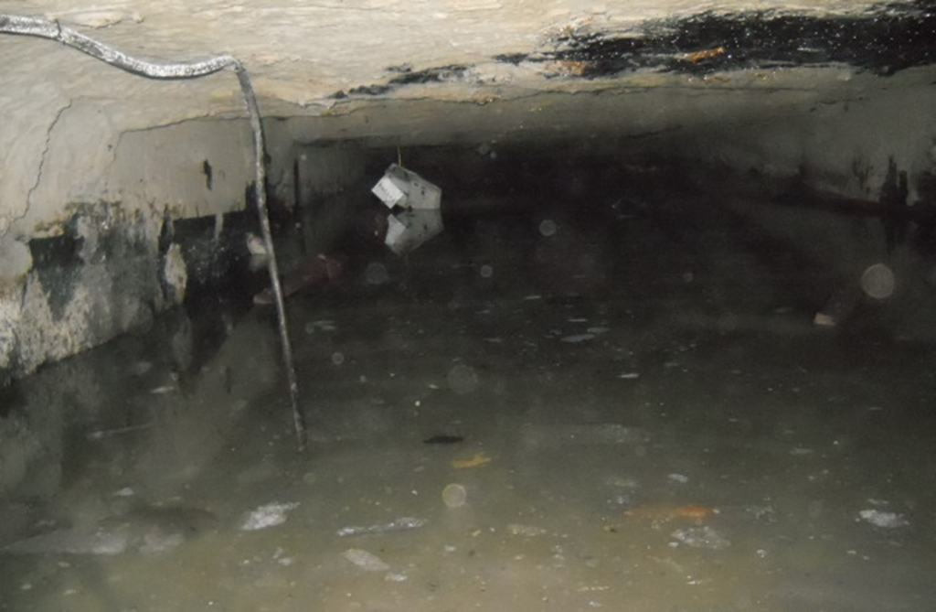

Best Practices
- Make sure miners de-energize, lock out, and tag out equipment before entering an area to perform repairs or maintenance.
- Make sure miners have communication systems available when assigned to work alone.
- Operators must conduct required examinations from safe locations to identify hazards, correct hazards, notify miners, and record hazards.

MINE FATALITY – On September 1, 2022, a roof bolter was electrocuted when he contacted a metal hook that became energized after it penetrated the 480-volt cable that supplied electrical power to a roof bolting machine.
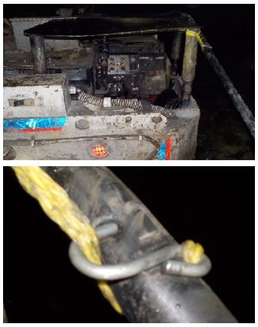

Best Practices
- Make sure miners use suitable, non-conductive ropes when pulling or handling electrical cables.
- Never attach conductive parts, such as metallic hooks, to the portions of non-conductive ropes that contact electrical cables.
- Make sure miners use proper Personal Protective Equipment when handling cables, such as insulated gloves.

MINE FATALITY – On August 17, 2022, a general inside laborer died when he was caught between a supply car and its coupler. The victim was sitting on the supply car which was coupled to a locomotive parked in a track spur. The locomotive was struck by another locomotive pulling three loaded cars into the mine. The impact knocked the victim off the supply car, killing him.
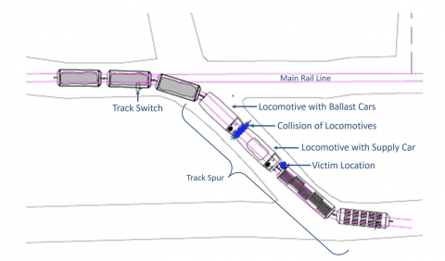

Best Practices
- Ensure track switches are in the proper position for your direction of travel and the latches are in contact with the rail.
- Make sure miners are in a safe location away from equipment parked in a track spur when other equipment is passing along the main rail line.
- Make sure miners communicate their location and intended movements with the dispatcher. Repeat the switch alignment back to the dispatcher, where applicable.

MINE FATALITY – On March 20, 2022, a 33-year-old miner died when he was struck by a roof fall while moving a waterline outby the retreat mining section. The intersection of the fall area was supported with five-foot fully grouted roof bolts and 10-foot cable bolts. The roof fall was approximately 40 feet long, 18 feet wide, and five feet thick.
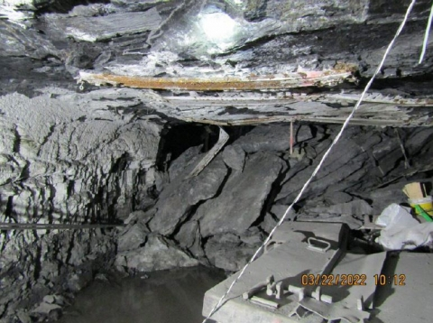

Best Practices
- Conduct a visual examination of the roof, face, and ribs immediately before any work is started in an area.
- Be alert for changing roof conditions, especially during retreat mining.
- Train miners on how to identify hazardous roof and rib conditions.

MINE FATALITY – On March 2, 2022, a miner was fatally injured when an overhang along the mine rib fell, striking the miner and pushing him against the canopy of a twin boom roof bolting machine. The miner freed himself from the fall, but later died.
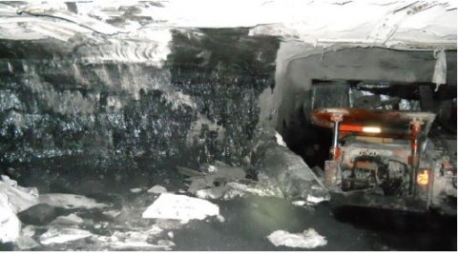

Best Practices
- Remove overhangs with the continuous mining machine.
- Install support of proper length with surface area coverage, on cycle, and in a consistent pattern for the best protection against falls.
- Examine the roof, face, and ribs immediately before starting work in an area where people work and travel, including sound and vibration testing where applicable.
- Scale loose roof and ribs from a safe location. Prevent access to hazardous areas until you take corrective measures.
- Take additional safety precautions when encountering new and changing roof and rib conditions.
- Train miners on how to identify hazardous roof and rib conditions.

MINE FATALITY – On February 28, 2022, a contract miner died when he was crushed between the rib and a single boom face drill. The victim was alongside the drill using the onboard tram lever controls when the accident occurred because the remote control was inoperable.
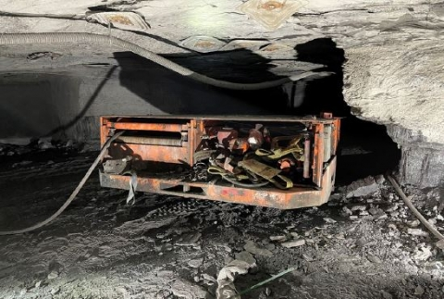

Best Practices
- Mobile equipment shall be maintained in safe operating condition. Immediately remove mobile equipment in unsafe condition from service.
- Always operate mobile equipment from a safe location. Use the remote control or operate from within the operator’s compartment if available.
- Determine the proper working position to avoid pinch points and Red Zone areas.
- Train miners on the safety aspects and safe operating procedures of mobile equipment before use. Review and discuss pinch points and Red Zone locations.

MINE FATALITY – On January 14, 2022, a 44-year-old contract laborer with 13 years of total experience received fatal injuries when he fell 27 feet to a concrete surface. At the time of the accident, the contractor was on a belt conveyor in a preparation plant and was working to replace a belt conveyor roller.
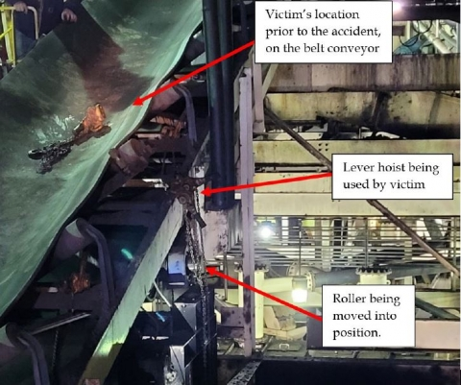

Best Practices
- Establish and follow safety policies and procedures, when working at heights.
- Train miners to use fall protection when a fall hazard exists.
- Ensure fall protection is available and properly maintained.
- Provide identifiable and secure anchor points to attach lanyards and lifelines.
- Provide mobile or stationary platforms—or scaffolding—where there is a risk of falling.

MINE FATALITY – On January 11, 2022, a 32-year-old miner died while driving on a mine road when a tree fell from a highwall onto the cab of his pickup truck.
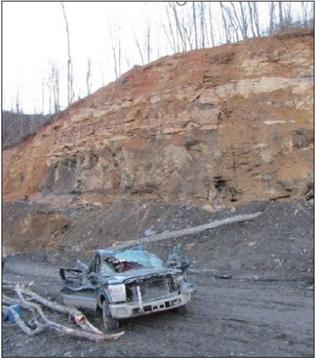

Best Practices
- Examine highwalls frequently and from as many perspectives as possible (bottom, sides, and top/crest). Look for signs of instability such as cracks, sloughing, loose ground, and for fall of material hazards such as large trees and rocks.
- Train all miners to recognize hazardous highwall conditions.
- Conduct additional examinations as conditions warrant, especially during periods of changing weather conditions.
- Clear loose or potentially hazardous material from near the edge of highwalls and slopes, especially when persons will work or travel below.
- Develop and follow a ground control plan that addresses all potential hazards.

MINE FATALITY – On January 7, 2022, a 35-year-old continuous mining machine (CMM) operator was fatally injured when he was pinned between the remote controlled CMM and the coal rib.
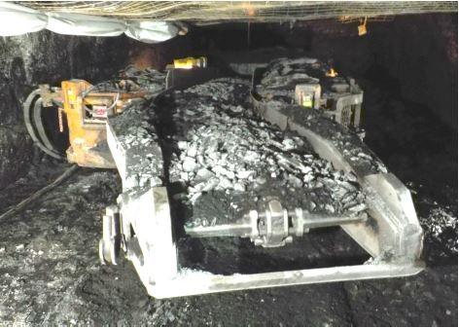

Best Practices
- Operate equipment from a safe location. Stay out of “Red Zone” areas including pinch points, the CMM turning radius, and areas close to the ribs.
- Maintain proximity detection systems (PDS) in the approved operating condition.
- Perform the manufacturer’s recommended static and dynamic tests to assure the PDS is functioning properly. Verify that the shutdown zones are at sufficient distances to stop the CMM before contacting a miner.
- Wear miner wearable components in accordance with PDS manufacturer’s recommendations so warning lights and sounds can be seen and heard.
- Develop and implement procedures for tramming, repositioning, cable handling and moving remote controlled CMMs safely.
- Train miners on the function of PDS.

MINE FATALITY – On December 4, 2021, a miner was performing maintenance duties on a continuous mining machine (CMM) when the raised CMM tail boom lowered, resulting in fatal crushing injuries to the miner.
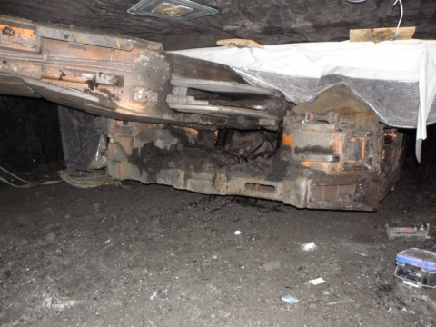

Best Practices
- Before performing maintenance and repair work:
  - De-energize the power source.
  - Open the visual disconnect.
  - Lock and tag the visual disconnect.
  - Securely block equipment against hazardous motion in accordance with manufacturer’s recommendations.
- Provide sufficient space around equipment to perform work safely.
- Develop and implement procedures to complete tasks safely.
- Train all miners to perform their assigned tasks safely.
- Operators should implement procedures to address hazards that cause injury.

MINE FATALITY – On November 1, 2021, an electrician with 25 years of mining experience was fatally injured while traveling down a mine slope. He lost control of a four-passenger rubber-tired personnel carrier, and the vehicle crashed at the bottom of the slope, pinning the victim underneath.
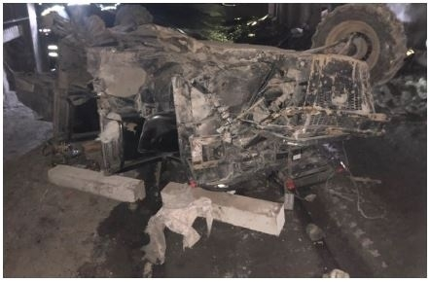

Best Practices
- Immediately remove equipment from service when defects affecting safety are found.
- Conduct adequate preoperational checks and weekly examinations of mobile electrical equipment. Correct any defects affecting safety before operating mobile equipment.
- Maintain control and stay alert when operating mobile equipment.
- Maintain roadways free of excessive water, mud, and other conditions that impact an equipment operator’s ability to control mobile equipment.
- Operate mobile equipment at speeds consistent with the conditions of roadways, grades, clearance, and visibility.
- Never rely on Regenerative Braking as a substitute for keeping brakes properly maintained.

MINE FATALITY – On October 19, 2021, a 58-year-old mechanic with 17 years of experience was fatally injured when the articulated haul truck bed collapsed on him while he performed maintenance on the truck.
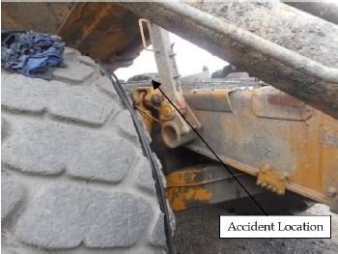

Best Practices
- Securely block from motion machinery or equipment that has been raised, and properly use mechanical blocking devices. Ensure that blocking material is competent, substantial, and adequate to support and stabilize the load.
- Position yourself in a safe location and away from potential “red zone” areas where you can be injured. Observe and follow all warning labels and signs on equipment.
- Never work under a load that is unsupported or inadequately supported, and never depend on hydraulics to support a load.
- Outfit haul trucks with a dump box lock bar that mechanically blocks the bed from coming down.
- Develop and follow safe work procedures.
- Always consult and follow the manufacturer’s recommended safe work procedures for the maintenance task.

MINE FATALITY – On August 11, 2021, a 53-year-old contract truck driver with ten years’ experience was fatally injured while conducting a pre-operational examination of a truck. The rear wheels of the vehicle struck the truck driver when the truck rolled forward.
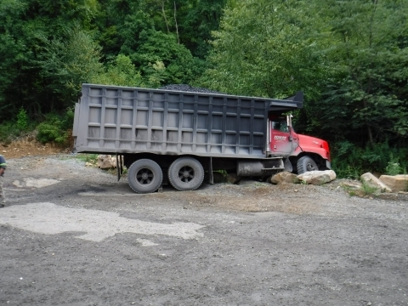

Best Practices
- Block mobile equipment against motion. Adequately chock wheels or turn wheels into a bank.
- Use specially designed truck-wheel chocks of the appropriate size and material to hold the vehicle securely. Do not use lumber, cinder blocks, rocks, or other makeshift items to chock.
- Never position yourself in hazardous areas around equipment parked on a grade that is not blocked or secured from movement.
- Maintain the equipment’s braking systems. Perform repairs and adjustments when necessary and follow the manufacturer’s recommendations. Do not exceed the manufacturer’s load limits.

MINE FATALITY - On Thursday, June 3, 2021, a 42-year-old section foreman was fatally injured when he was hit by a shuttle car. The victim was struck when he walked into the path of a loaded shuttle car that was traveling to the dump point.
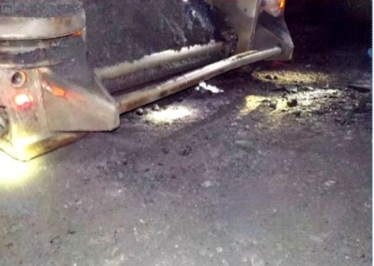

Best Practices
• Install proximity detection systems on mobile equipment to protect personnel and eliminate accidents of this type.
• Be aware of your location in relation to movement of equipment, especially in lower seams.
• Sound audible warnings, distinguishable from surrounding noise, and reduce speed when approaching and before traveling through check curtains. Wear reflective clothing or strobe lights to aid visibility when working around mobile equipment.
• Ensure all personnel are clear of the traveling path and turning radius before moving equipment.
• Train miners and equipment operators to communicate their location and wait for acknowledgement before moving.

MINE FATALITY – On June 2, 2021, a 26-year-old section foreman with five years of mining experience was pinned against a continuous mining machine by a piece of rib. The piece fell while he was installing a rib bolt with the machine mounted rib drill.
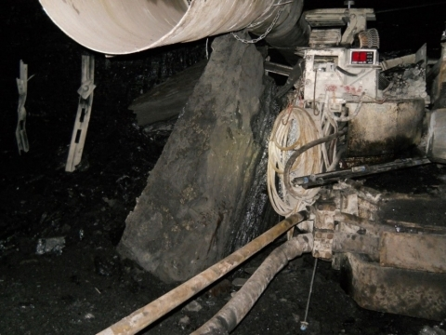

Best Practices
- Support loose roof and rib material adequately or scale loose material from a safe location before working or traveling in an area.
- Examine the roof, face and ribs immediately before starting work in an area and throughout the shift as conditions warrant.
- Take additional safety precautions when mining heights increase and in areas where mine conditions change.
- Train miners to recognize roof and rib hazards and to stop work in the area until the hazards are corrected.

MINE FATALITY – On May 14, 2021, a continuous mining machine operator was fatally injured when a piece of rock fell from the roof and struck him. The victim was working under unsupported roof in the Number 1 entry.
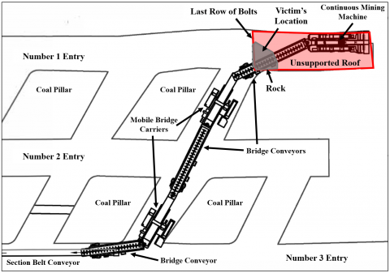

Best Practices
- Never work or travel under unsupported roof.
- Thoroughly examine the roof, face and ribs where people will be working and traveling, including sound and vibration testing.
- Scale loose roof and ribs from a safe location. Prevent access to unsupported and hazardous areas until appropriate corrective measures can be taken.
- Follow the approved roof control plan and provide additional support when cracks or other abnormalities are detected. Never exceed the maximum cut depth specified in the approved roof control plan.
- Mark the second to last row of bolts with reflective material and train miners not to travel inby this location.
- Train miners to identify hazards from the roof, face and ribs.

MINE FATALITY – On Jan. 22, 2021, a shuttle car operator with 11 years of mining experience was in the operator’s compartment of his shuttle car, traveling through the last open crosscut, when a second shuttle car traveled through a ventilation curtain and struck his shuttle car. The corner of the second shuttle car entered the operator’s deck of the victim’s shuttle car. The operator was injured and passed away from the injuries on Feb. 21, 2021.
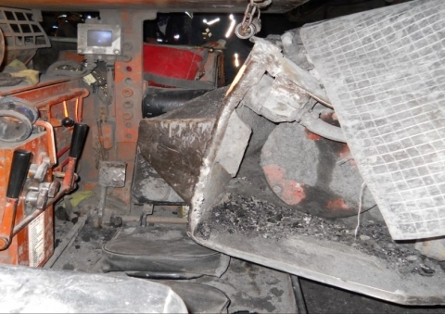

Best Practices
- Install and maintain proximity detection systems on mobile section equipment.
- Communicate your presence and intended movements. Wait until miners acknowledge your message before moving your equipment.
- Do not tram equipment through ventilation curtains. Tram only through fly pads in designated haulage routes.
- Use clear curtains for fly pads and ventilation controls on working sections.
- STOP and SOUND an audible warning device before tramming equipment through fly pads. Ensure directional lights are on when operating mobile equipment.
- Avoid areas where equipment operators cannot readily see you.
- Wear personal strobe light devices to increase visibility.

